**Nikroshitha A Notani**

**Flight Price Prediction**

**Source : Kaggle**

**Link : <https://www.kaggle.com/datasets/shubhambathwal/flight-price-prediction/data>**

**December 13, 2023**

**Professor Dipak Biscuitwala**

**Introduction**

The primary goal of this project is to develop a predictive model for flight prices using the dataset "Flights.csv." This dataset contains valuable information about flight bookings, including various features that can influence ticket prices. The objective is to leverage machine learning techniques to predict flight prices accurately. Flight price prediction is of great significance for travelers, travel agencies, and airlines to make informed decisions regarding ticket purchases, planning, and pricing strategies.

**Five Features**

The "Flights.csv" dataset encompasses several key features that will be utilized for flight price prediction:

1. Airline: Categorical feature representing the airline company.

2. Flight: Categorical feature indicating the flight code.

3. Source City: Categorical feature denoting the departure city.

4. Departure Time: Categorical feature derived from time intervals, indicating departure times.

5. Stops: Categorical feature representing the number of stops during the journey.

6. Arrival Time: Categorical feature derived from time intervals, indicating arrival times.

**Research Questions:**

The project aims to answer the following research questions:

a) Can we accurately predict flight prices based on airline, departure and arrival cities, departure and arrival times, and other factors?

b) Which features have the most significant impact on flight prices?

c) How well does the predictive model perform in estimating ticket prices?

d) Can the model provide valuable insights for travelers, travel agencies, and airlines to make pricing and booking decisions?

By addressing these research questions, the project intends to provide a reliable flight price prediction model that benefits various stakeholders in the travel industry and empowers travelers to make informed choices.

**Explanatory Analysis of Flight Price Prediction**

The objective of this project is to predict flight prices accurately, providing travelers with valuable insights for budgeting and decision-making. Flight prices are influenced by a multitude of factors, such as time of booking, airline, time of travel, and route complexity. The analysis aims to uncover patterns within the data to enhance prediction accuracy.

**Transforming the Dataset:** To better address these questions, new variables were created through a process of aggregation and transformation:

**Booking Lead Time:** Calculated as the difference between the booking date and the departure date. This helps identify patterns related to how far in advance tickets are booked.

**Day of the Week:** Extracted from the departure date to analyze if certain days have lower or higher prices.

**Month of Travel:** Extracted from the departure date to explore seasonal trends in flight prices.

These variables were chosen to provide insights into the impact of timing on flight prices, aiding in the creation of a predictive model.

**Purpose of Visualizations:**

**Histogram of Flight Prices:** Illustrates the distribution of flight prices, helping identify outliers and understand the overall range of prices.

**Scatter Plot of Booking Lead Time vs. Price:** Examines how the time between booking and departure correlates with prices, guiding users on the optimal booking period.

**Bar Chart of Average Prices by Airline:** Compares the average prices of different airlines, aiding users in choosing cost-effective options.

**Line Chart of Average Prices by Month:** Reveals any seasonality in flight prices, assisting travelers in planning budget-friendly trips.

**Visualizations**

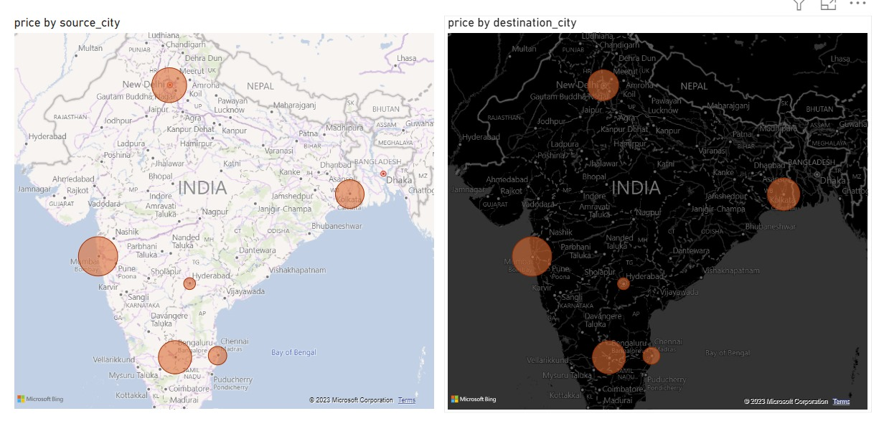

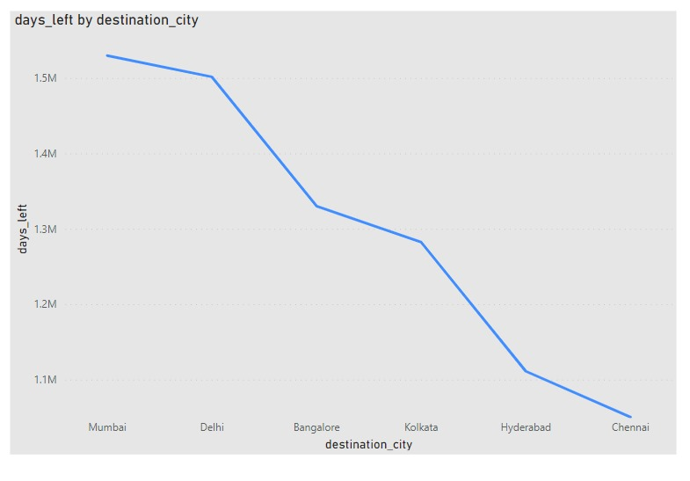

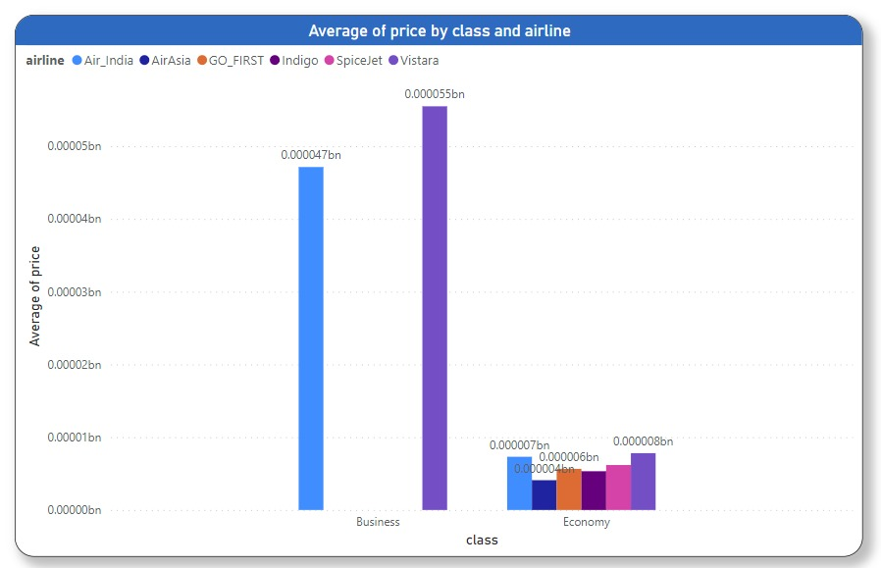

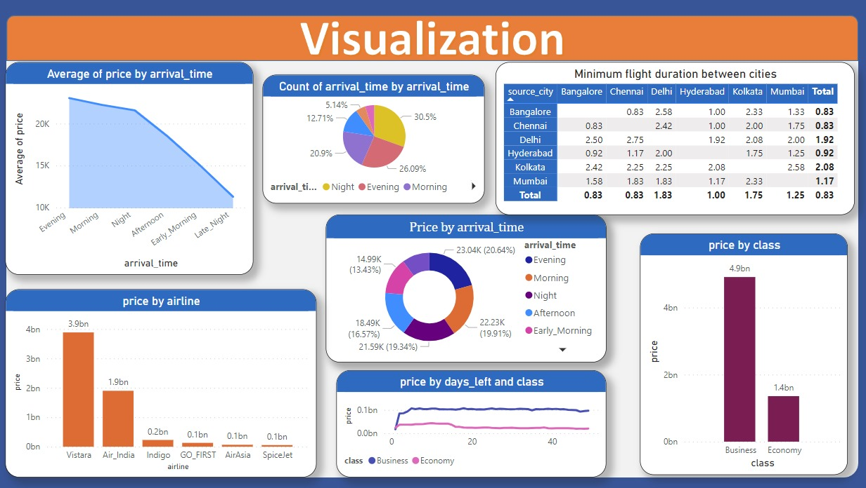

**Outcome and Importance:** The exploratory analysis uncovered valuable insights into the factors influencing flight prices. For instance, flights booked 2-3 months in advance tend to have lower prices, and certain airlines consistently offer more affordable options. Additionally, specific months and days of the week exhibit trends that can guide users in making informed decisions.

**Conclusion:** Understanding the patterns in flight prices can empower travelers to make informed choices. The predictive model developed based on these insights can offer even more accurate forecasts, allowing users to plan their trips economically. The increased accuracy in predicting flight prices can have a significant impact on travel planning, providing users with a competitive advantage in securing the best deals.